EXPERIMENT 21
CODE:-#include <stdio.h>

int main() {
int block[20], process[20], allocation[20];
int b, p, i, j, worst;

printf("Enter number of memory blocks: ");
scanf("%d", &b);

if (b < 1 || b > 20) return 1;

printf("Enter block sizes:\n");
for (i = 0; i < b; i++)
scanf("%d", &block[i]);

printf("Enter number of processes: ");
scanf("%d", &p);

if (p < 1 || p > 20) return 1;

printf("Enter process sizes:\n");
for (i = 0; i < p; i++) {
scanf("%d", &process[i]);
allocation[i] = -1;
}

for (i = 0; i < p; i++) {
worst = -1;

for (j = 0; j < b; j++) {
if (block[j] >= process[i]) {
if (worst == -1 || block[j] > block[worst])
worst = j;
}
}

if (worst != -1) {
allocation[i] = worst;
block[worst] -= process[i];
}
}

printf("\nProcess\tSize\tBlock\n");

for (i = 0; i < p; i++) {
printf("P%d\t%d\t", i + 1, process[i]);

if (allocation[i] == -1)
printf("Not allocated\n");
else
printf("%d\n", allocation[i] + 1);
}

return 0;
}
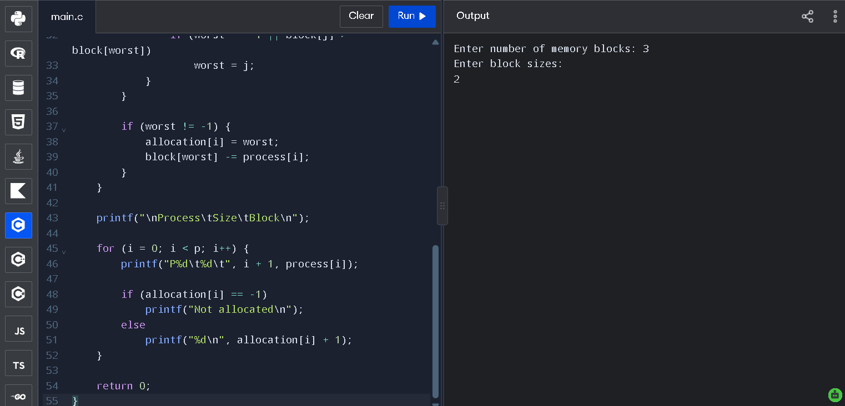
Output:-

